Editorial shoot submission form (2 pages)

[see separate guidelines for real weddings - this form is for styled photoshoots only]

IMAGES:

Please send me a link to a Dropbox folder containing 60ish of your most beautiful, bloggable images. Please note I ONLY use Dropbox for submissions; no other file sharing service.
Images should now be 1024px wide (not longest edge! Even portrait orientation images need to be this width

Please complete all the information on this form and save it in your Dropbox as a Word or Pages document.

Email the link to info@english-wedding.com
_______________________________________________
What should we call your shoot?

How should we introduce your shoot?
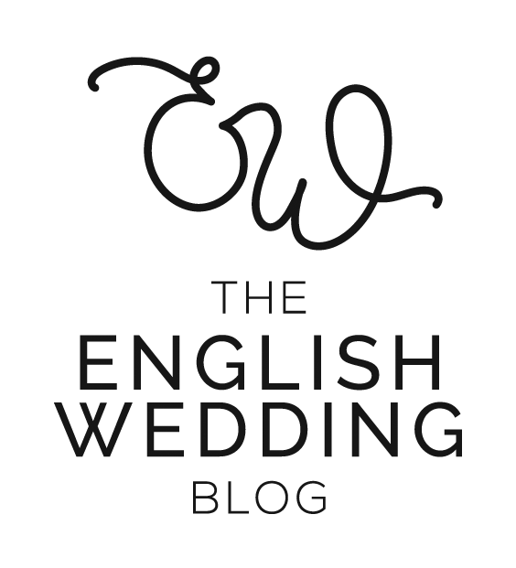
e.g. “This is festival wedding style taken to the next level! We styled an incredible backdrop and made the most of the natural surroundings at [venue]. Our brides are a real couple, dressed in stunning separates by [designer]. The florals are amazing - [florist] took our breath away with his playful use of colour and texture…

Add as many paragraphs as you like here - we’ll copy and paste it onto the blog.

Supplier websites - please complete the list below
Format: https://english-wedding.com
(Categories are given as examples. Please add or remove as appropriate)

Photographer -
Stylist -
Venue -
Dress designer (this one’s important for us!) -
Bridal boutique -
Suit designer -
Florist -
Stationery -
Cake -
etc.

Instagram handles - please complete the list below
Format: @englishweddingblog
(Categories are given as examples. Please add or remove as appropriate)
Photographer -
Stylist -
Venue -
Dress designer -
Bridal boutique -
Suit designer -
Florist -
Stationery -
Cake -
etc.

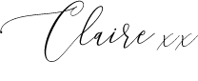
Please save this list as a Word or Pages document and include it in your Dropbox when you submit. Email the Dropbox link to me at info@english-wedding.com

Thank you!

