Editorial shoot submission form (2 pages)

[see separate guidelines for real weddings - this form is for styled photoshoots only]

IMAGES:

Please send me a link to a Dropbox folder containing 60ish of your most beautiful, bloggable images. Please note I ONLY use Dropbox for submissions; no other file sharing service.
Images should now be 900px wide (not longest edge! Even portrait orientation images need to be this width

Please complete all the information on this form and save it in your Dropbox as a Word or Pages document.

Email the link to info@english-wedding.com
_______________________________________________
Title of your shoot:

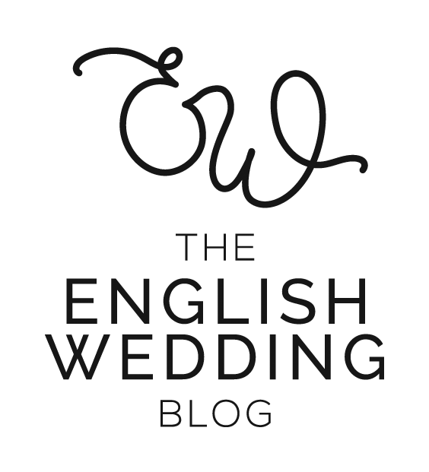
Introductory paragraphs:
What can our readers learn / take from your shoot? Who’s it for? (Imagine you’re talking to a bride and groom.) Tell us how you brought the style and concepts together, and how they can incorporate these ideas into their day.

Supplier websites - please complete the list below
Format: https://english-wedding.com
(Categories are given as examples. Please add or remove as appropriate)

Photographer -
Stylist -
Venue -
Dress designer (this one’s important for us!) -
Bridal boutique -
Suit designer -
Florist -
Stationery -
Cake -
etc.

Instagram handles - please complete the list below
Format: @englishweddingblog
(Categories are given as examples. Please add or remove as appropriate)
Photographer -
Stylist -
Venue -
Dress designer -
Bridal boutique -
Suit designer -
Florist -
Stationery -
Cake -
etc.

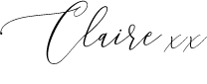
Please save this list as a Word or Pages document and include it in your Dropbox when you submit. Email the Dropbox link to me at info@english-wedding.com

Thank you!

